Title: Powerful You

Authors: Alexis Alonso - Pompano Beach High School

Ansley White - St. Thomas Aquinas High School

Haerunnisa Dewindita - Cypress Bay High School

Abstract: The following sections to be discussed will include: a background of our two year internship at the Museum of Discovery and Science along with our chosen exhibit, explicitly detailed methods implemented in the creation of our phone application, a showcase of our resulting project along with a brief outline, a discussion on any projected extensions or add-ons to fully complete the app as a final outcome, conclusions on our personal feelings and experiences during this opportunity along with references as to where to locate the source code and previews, and any acknowledgements/credits to the people and references that made this process possible.

Background: Our group’s internship at the Museum of Discovery and Science, currently in its first year stage, began as exploring the physical aspects and significant background foundations of the museum itself to build our awareness of it’s functions and needs in order for us to develop an application that will correspond to the museum and improve its features with a more personal user and technology experience. The exhibit we had chosen, Powerful You, already possessed a significant degree of high-tech and modern attributes, corresponding to today’s modern medical technology, but lacked a mobile and individual audience characteristic in its many contemporary facets.

Methods: This app development class, taught by Dr. Ravi Shankar and Prof. Francis McAfee, had multiple groups responsible for various exhibits in the museum and each individual group had a person responsible for one of the following jobs: User Interface, Java, and Graphics. Each person works on a special characteristic of the app and the groups would meet up together to implement each element together and join them. For our group, Alexis had been assigned the position of graphics creation and put together the visual art components of our Powerful You application. Her work included the Joey the Otter yoga positions, which were an awfully cute addition in our mostly serious informative medical approach, the simple monochromatic front screen buttons that keeps a clean and sleek theme, and the creative graphic put in our Emergency Statistics page (which put together all the emergency instances simultaneously in one event portrayed in a graphic). Ansley was responsible for the user interface, which created the scaffolds of the visual element of the app. Her hard work was put into the positions and basic look of the application (later enhanced with graphics) to please the museum audience and put ease into transitioning within the app. Haerunnisa, more easily called Dita, had the job of working with the Java component of this project. Her work was exemplified in the literal functions of the applications, which included the page transitions, button pop-ups, broadcast intent, and programming aspect of the app’s infrastructure itself. Individually, our group had very strong solo parts, which altogether, created an application we are very proud of and left little room for fixing major problems since we did not come across any. On the topic of problems, our group’s methods to solve them were limited; we were very realistic with our goals and realized the boundaries of computer programming we had considering our environment before the jump into project creation. Because of this, putting together our app was much more smooth due to our realistic goals. That had lessened any potential problems we might have run into if our projections were too advanced for three high school girls in a nine-day app development course. Even if we came across any problems of this type, our group’s great chemistry and developed friendships will help us overcome those bumps in the road and our current methods of talking things out will aid in solving. In addition, we communicate quite frequently and were always aware of what the other needed.

Results: Our mobile application was able to provide an aesthetically pleasing rendition of the Museum of Discovery and Science, Powerful you exhibit. We separated our application into 5 different subcategories under the Powerful You exhibit umbrella so that viewers were able to capture the true essence of the health message captured within the exhibit. First, the “Health” sector of our application allows viewers to learn about the importance of being health in habits like eating. We were even able to include a health quiz where app-users can test their skills and learn supplemental information after they click on the correct answer. We were very happy that our application included a quiz because we felt it increased the interaction between user and creator. Our application also resulted in subdivisions like “Strength,” “Emergency,” and “Medical.” These subdivisions resulted in a similar format to that of the “Health” sector where information was presented followed by a supplemental feature like yoga poses under strength where viewers can learn how to be healthy in their exercise ways or statistics under emergency where viewers can really see the numbers surrounding the dangers in everyday life. Lastly, our application provides a “Hygiene” division where we encourage the visitors to visit the sanitizing stations around the Museum of Discovery and Science. Our application does many things besides just inform, and I think that is what we aimed to accomplish.

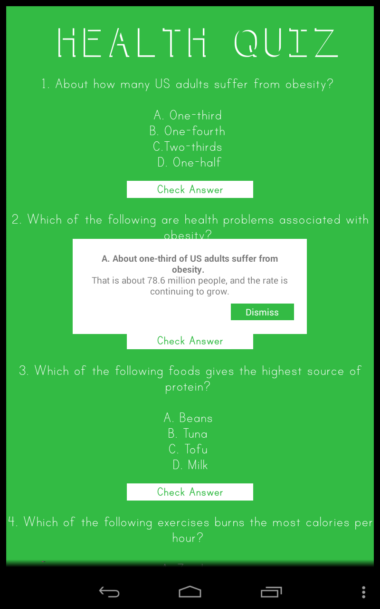 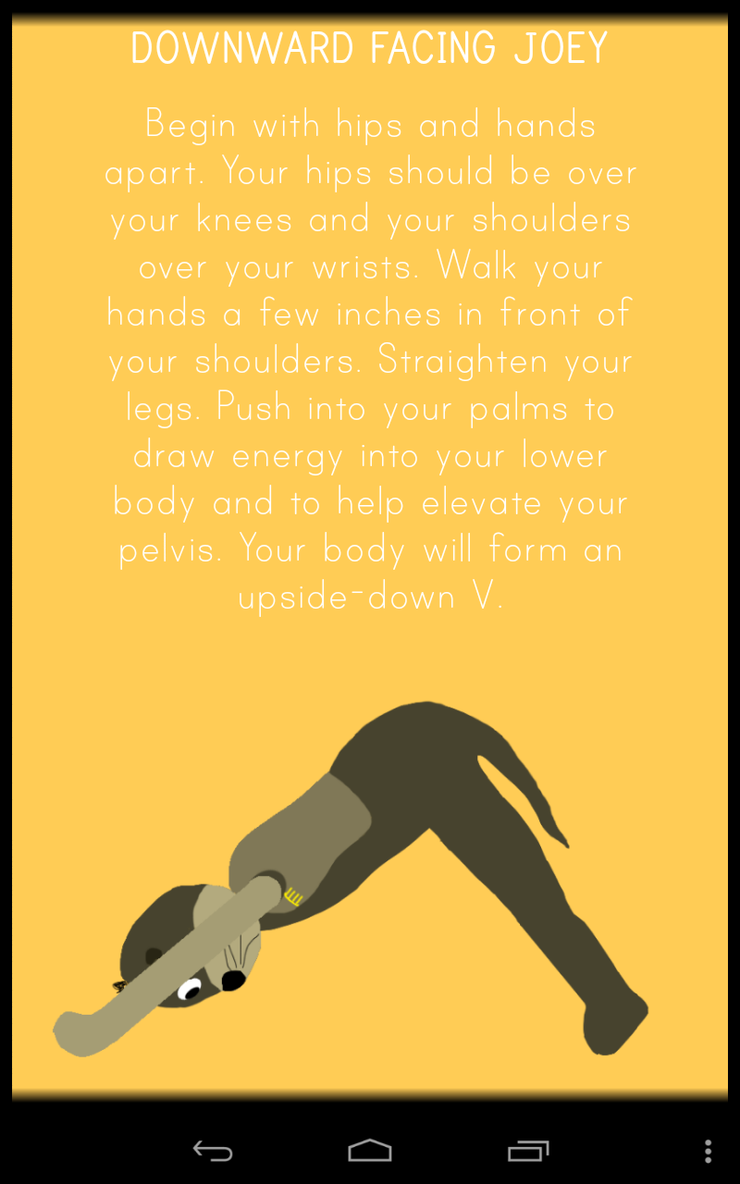

Discussion: Although we worked very hard during the entirety of this class program, there are further extensions that can be made so that it further meets the needs of those who will be using it. This application could be described as a “complete app” but to further complete it we think that there should be more interactive features added. We have multiple interactive features, but nearly half of our app is made up of information which we all know most people will not read. This app could be completed by extending that information into fun games and activities that make people learn while still not losing their attention span. To further complete the app, we would also like to draw a closer relationship between the physical exhibition itself and the app. We were able to draw some connections, but further completion could involve some way that the app connects to parts of the exhibit where people are directly using the Museum’s facilities. A scavenger hunt may be a good way to do this so that visitors will want to go around and discover the unsung components of the exhibit. Further extension is needed to go with the changing times of technology use.

Conclusions: We, as the Powerful You exhibit group, feel as though we have accomplished so much in our app and throughout this entire program. Starting out in this program almost a year ago, we were a bit shell-shocked about what this program, in particular the class, would entail. It took awhile for even our class to grow as a family in a sense, and there was a time when we were scared we would never feel comfortable enough to work together. Now, in the end, we are able to combine our ideas, and we are proud to present what we have made to those who see it. We feel that the app we present demonstrates hard work and dedication. We also feel that we were able to produce an app from the standpoint that we would want to use it. Our app also makes us feel proud of what we accomplished because it comes from three high school girls who, even with some experience with coding in Java, struggled through yet persevered. We were all so scared our first day with all the downloading of programs and such. Yet, in the final days of this program, we are excited to know that we can fully navigate around Android Studio and Photoshop. We feel that what we have accomplished shows our arduous character, and that is something we are proud to share. Our app project folder can be found under the Powerful You group in the MODSAPP Github user. The Repository is where we have our listed project folders with screenshots of logcat.

Acknowledgements/Credits: We could not have made it through this program without the help of countless organizations and people. We first would like to thank our schools for helping us get into this program: Alexis Alonso thanks Pompano Beach High School; Ansley White thanks Saint Thomas Aquinas High School; Haerunnisa Dewindita thanks Cypress Bay High School. We would also like to thank the Museum of Discovery and Science for being our fundamental foundations in this entire program. Within the Museum, we would like to especially thank Summer Scarlatelli and Joe Cytacki for being our mentors and supervisors. We also thank Florida Atlantic University for providing the class an opportunity to learn. In particular, Dr. Ravi Shankar and Francis McAfee for teaching us everything we needed to learn. Lastly, we would like to thank our online textbook for being a resource we could use when we were confused. We made use of the “Android Studio Development Essentials” book the most.

References: There were many things that were key to the success of our project. The people and organizations that were named above were completely fundamental of evening getting this class done. We also referenced the information at the museum for the content part of our information and our quiz. Within our technology, we referenced Android Studio to help us complete the project and make it successful on the User Interface and Java sectors of this project. Lastly, in Graphics Alexis referenced Photoshop to complete our aesthetic appeal. Without the help of the things above, our project would not have been nearly as successful.